**10-02-2019 Smoke test (10 vu)**

**Test purpose**

The purpose of the test was to check that the functionalities of the BlogEngine application are working correct and environment is working stably during using the application by clients with Anonymous role. The number of generated blog posts is 1000.

**Environment:** Analysis was performed on TEST environment.

General info:

|  |  |  |  |  |  |
| --- | --- | --- | --- | --- | --- |
|  | **Host** | **Type** | **IP** | **Hosted Applications** | **Ports** |
| STAGING | EPUAKIYW1844T2 | VM | 10.17.175.58 | EPUAKIYW1844T2.kyiv.epam.com | 80, 443 |

System resources (TEST env):

|  |  |  |  |  |
| --- | --- | --- | --- | --- |
|  | **Operational System** | **CPU, GHz** | **Memory, Gb** | **Disk size, Gb** |
| **DGL** | Win Server 2010 R2 SP1 64bit | 2 | 4 | 50 |

**Test status**

Successful - tests were stopped on 8th and 11th minutes for the first and second type of scenarios respectively as the application became unresponsive.

**Test scenario**

There are considered Main script for Anonymous user scenario for two type of probability usage where

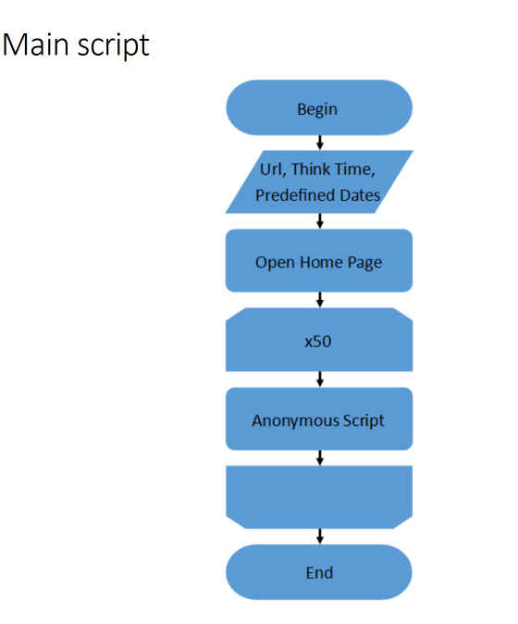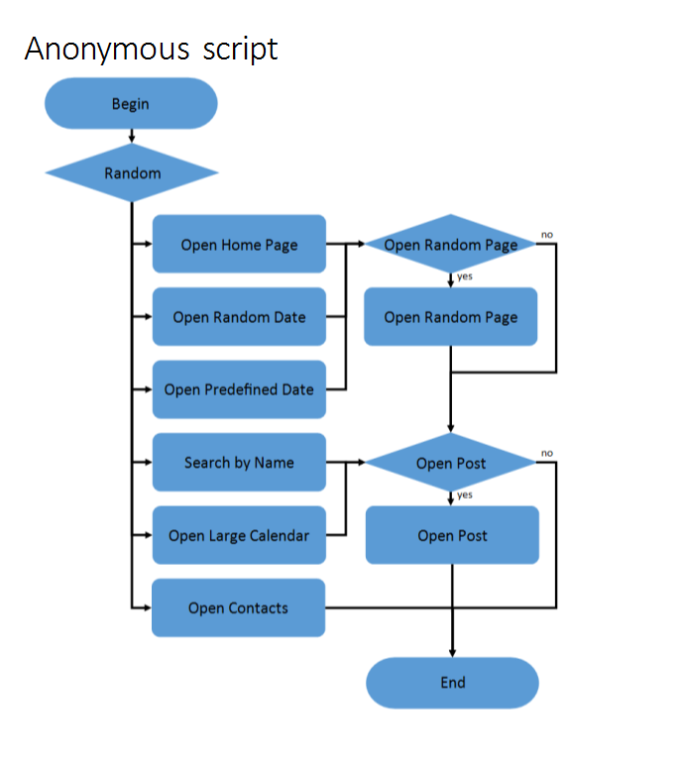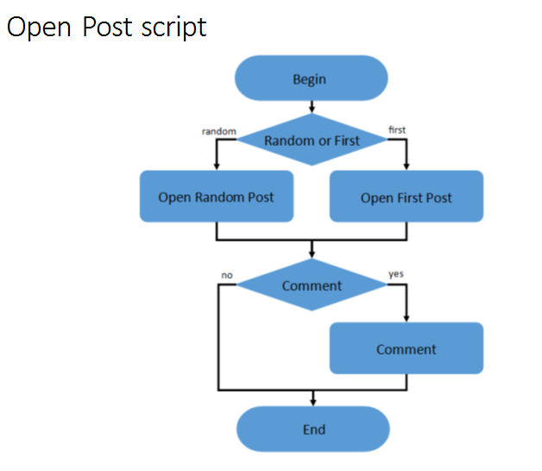

Test conditions

|  |  |  |  |
| --- | --- | --- | --- |
| Condition | Transaction | First probabilities usage | Second probabilities usage |
| 1 | open home page | random | 15% |
| open random date | 10% |
| open prediction date | 30% |
| search by name | 30% |
| open large calendar | 10% |
| open contacts | 5% |
| 2 | open random page | 50% | 50% |
| 3 | open post | 50% | 80% |
| 4 | open random post | 50% | 65% |
| open first post | 50% | 35% |
| 5 | add comment | 50% | 20% |

Test Setup

|  |  |
| --- | --- |
| number of virtual users | 10 |
| ramp-up period | 100 |
| think time between transactions(sec) | 3-5 |
| count of posts | 100 |

Note: here random date is from 2019-02-01 to 2019-02-11.

Test Results

|  |  |  |
| --- | --- | --- |
| KPI | First Condition | Second Condition |
| number of estimated transactions/sec (max) | up to 716 | up to 1205 |
| requests/sec (max) | up to 29 | up to 32 |
| CPU | up to 100% | up to 100% |
| saturation point (users) | 10 | 19 |
| crash point (min) | 8 | 11 |
| crash point (users) | 23 | 30 |
| average median response time (ms) | 35 | 29 |
| average 95% response time (ms) | 119 | 55 |

**Test Summary**

1. The maximum capacity of the application usage by Anonymous clients is found. For both scenarios it is restricted by the 100% CPU usage. Adding more load leads to the application becomes unresponsive.

2. Saturation point is 10 users and crash point is 23 for the 1st scenario. Saturation point is 19 users and crash point is 30 for the 2d scenario.

**Issues found**

"Add Comments" transaction showed nearly 1.5% error rate during the test. This may be caused by the concurrency during access to the same resource (post).

**Recommendation**

Possibility to increasing CPU power.

**Result detail**

There is suppose that these results depend from random date value, it will be good to execute the addition test with another random date for comparison the results.

**Results: graphs and tables**

1. Aggregate Reports

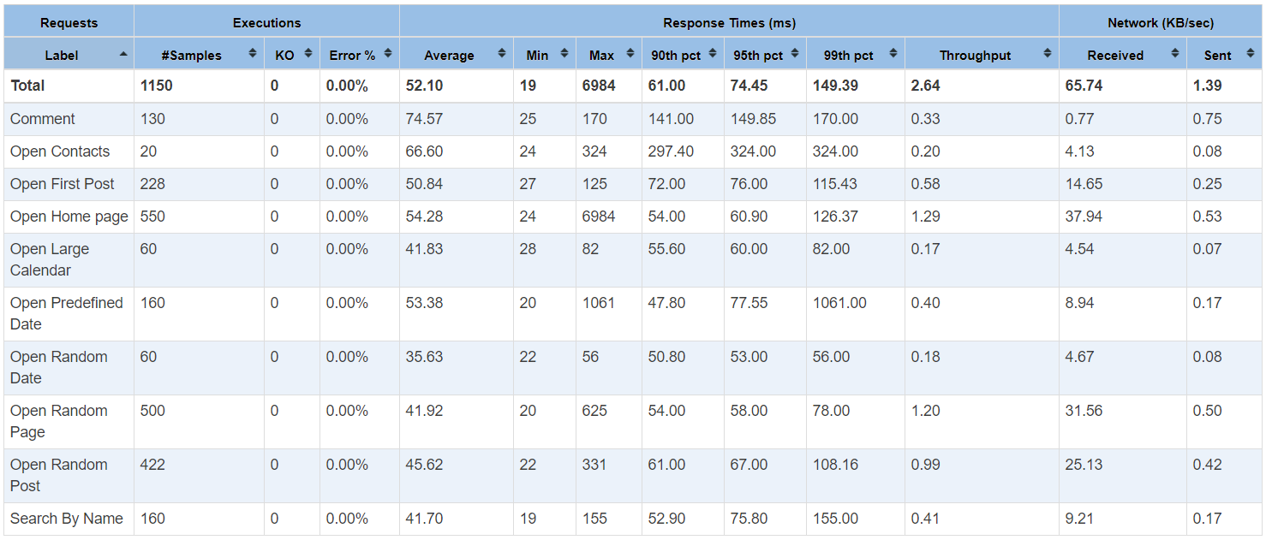

1. Number of active threads graph

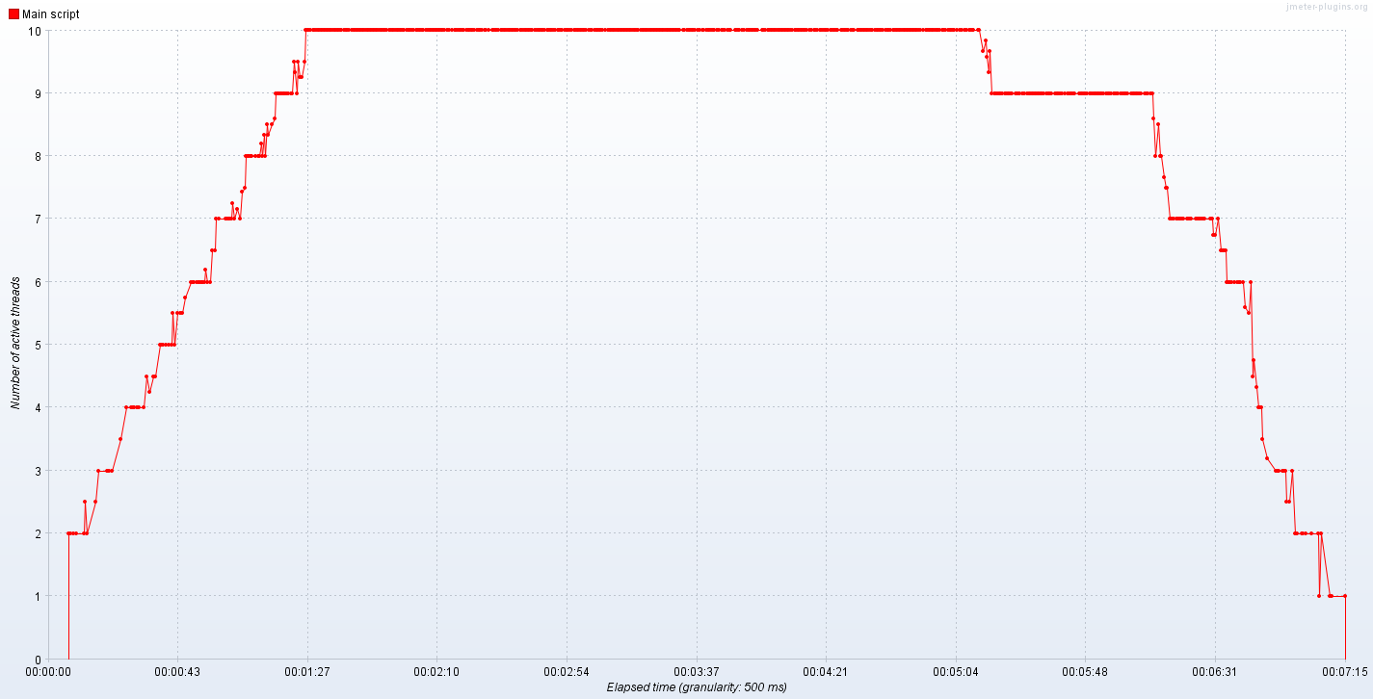

1. PerfMon Metrics (CPU and Memory) graphs

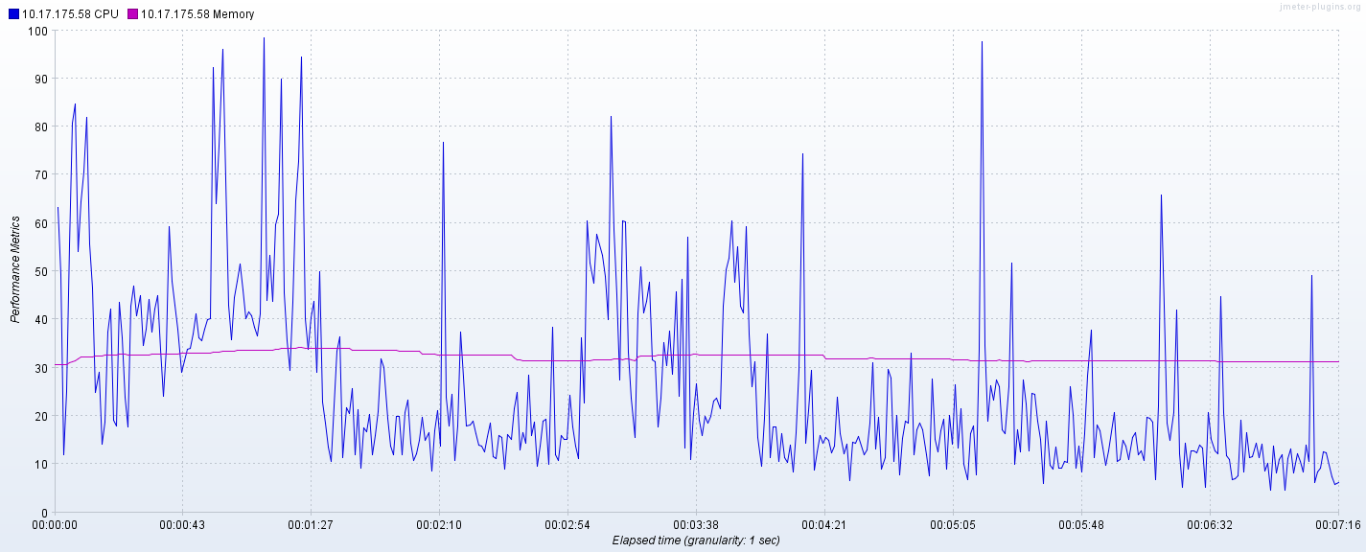

3. Transaction Throughput vs Threads graphs

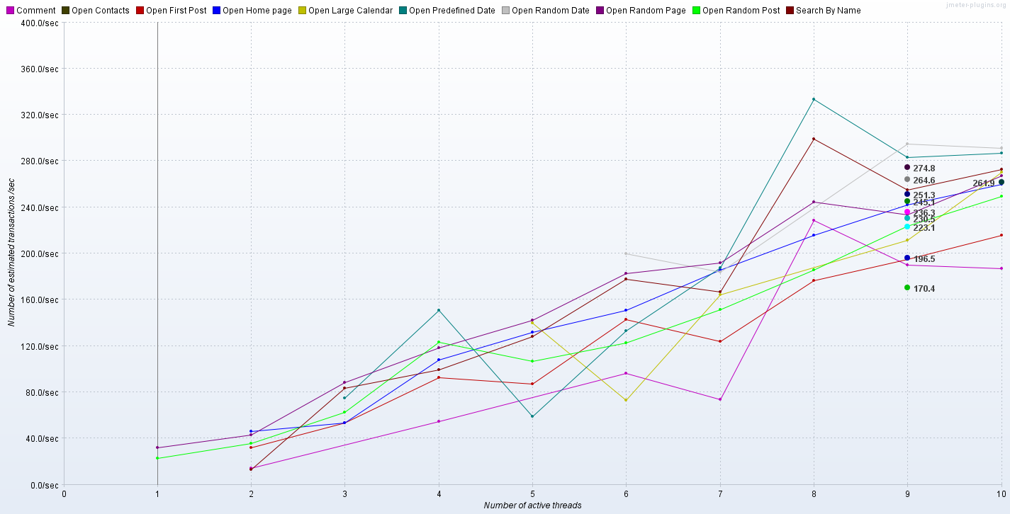

From these graphs we obtained saturation points. For first condition saturation point is 10 users and for second condition – 19 users.

1. Response codes per Second graphs

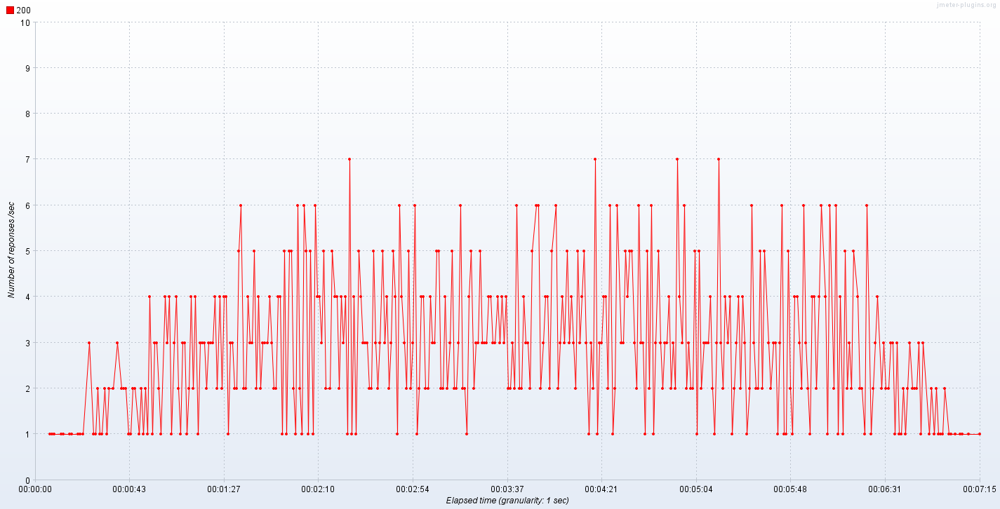

1. Response Time Over Time

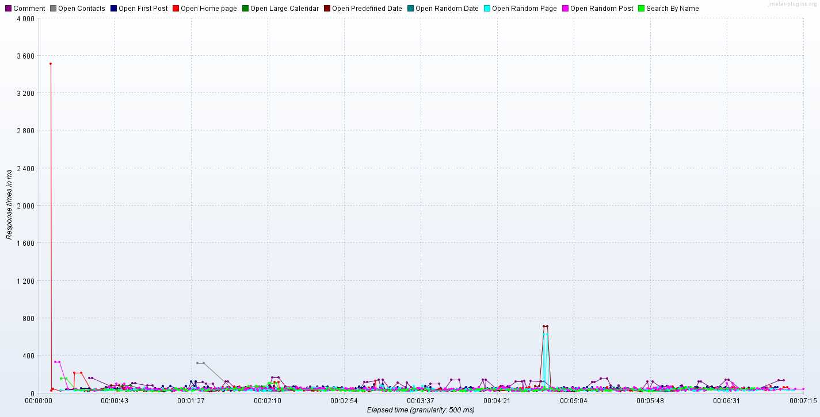

1. Error details

Conclusion

[optional]